CHOOSE THE RIGHT!!!

Student Success Statement

“Real wealth is not so much what we have as what we are.”
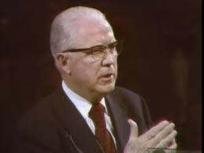

Sterling W. Sill

